- Write R programs for basic tasks: Factors of a number, generate a vector of 10 random integers between -50 and 50, print numbers 1–100 with FizzBuzz logic.

Aim:
To write R programs for basic tasks: Factors of a number, generate a vector of 10 random integers between -50 and 50, print numbers 1–100 with FizzBuzz logic.
Procedure:
Step 1: Open RStudio or R console on your system.
Step 2: Assign an integer value to a variable to represent the number for which factors are to be found.
Step 3: Initialize an empty integer vector to store the factors.
Step 4: Use a for loop to iterate through all numbers from 1 to the given number.
Step 5: Inside the loop, use the modulus operator to check if the number divides evenly (remainder equals 0).
Step 6: If the condition is true, append that value to the factors vector. Step 7: After the loop completes, print all the factors of the given number.
Step 8: Set a random seed to ensure the random number generation gives reproducible results.
Step 9: Generate and print 10 random integers within a specified range (−50 to 50). Step 10: Use another for loop to iterate from 1 to 100 and apply the FizzBuzz logic: Print “FizzBuzz” for numbers divisible by both 3 and 5.
Print “Fizz” for numbers divisible only by 3. Print “Buzz” for numbers divisible only by 5. Otherwise, print the number itself.
Step 11: Display the complete sequence of printed outputs to verify the logic.

Code:
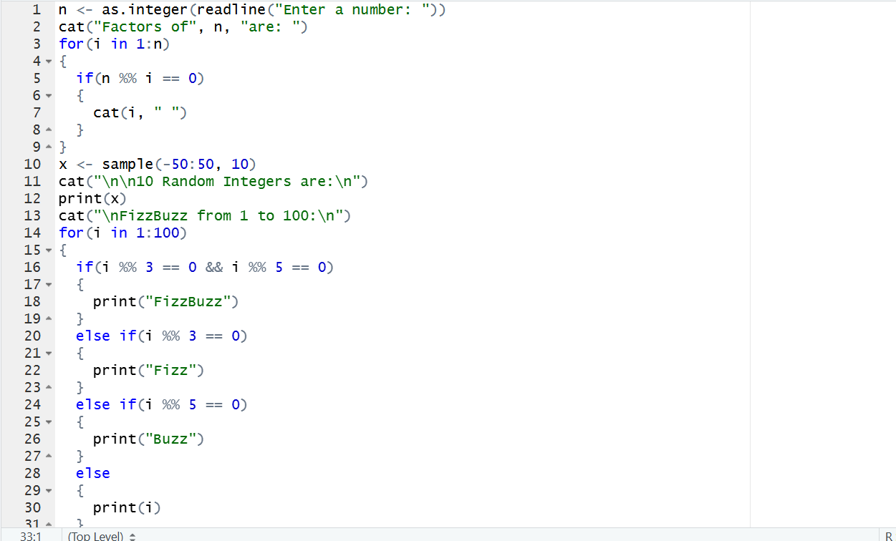
Output:
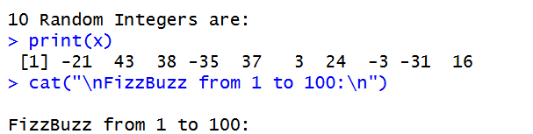
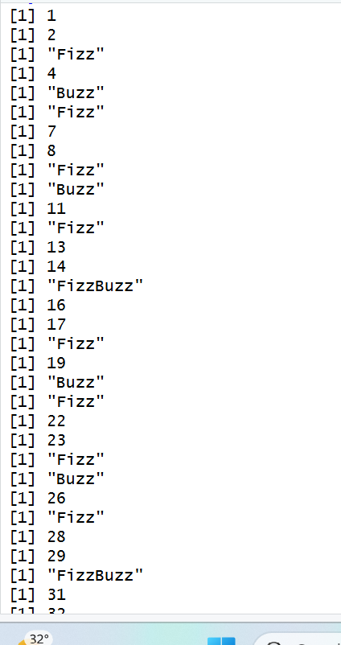
Result:
Hence the output is verified successfully.

